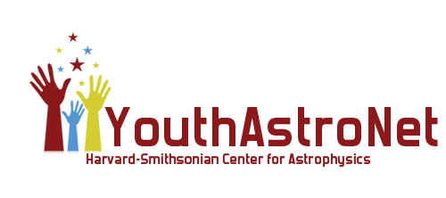

**We Want YOU!**

The Center for Astrophysics | Harvard & Smithsonian invites enthusiastic educators of middle-school-age youth to join our [Youth Astronomy Network](https://youtu.be/1MydptnTom0) (YouthAstroNet)!

YouthAstroNet is a nationwide online learning community of grades 5-8 students, educators, and STEM mentors that features remotely-controlled, online telescopes from the Center for Astrophysics, and complementary resources and activities. Using the [MicroObservatory Robotic Telescope Network](http://microobservatory.org/) youth and their adult program facilitators can take their own images to explore the Moon, Sun, planets, stars, and galaxies; use professional image analysis software; and do hands-on activities to investigate more about space, and the technologies that operate the robotic telescopes.

**Benefits and resources:**

* Ongoing support from astronomy and science education experts from the Center for Astrophysics.
* Customized online access to MicroObservatory Telescope Network and YouthAstroNet resources, including group accounts for managing and monitoring student activity.
* Kid-tested activity/lesson plans for after-school programs, science clubs, or other informal learning environments.
* Live and archived webinars, video-tutorials, and online discussion groups for learning how to implement YouthAstroNet activities with youth.
* Resources for introducing youth to 21st Century Skills, and IT and STEM careers related to their use of robotic telescopes and digital image processing tools.
* Tools and guides for hosting local *YouthAstroNet* community/capstone events
* Connections to NASA and real scientists!

**How to Get Involved**

YouthAstroNet staff are offering a self-paced online training for any educator wishing to provide this resource to their students. Project staff will be available to share feedback and support via online forums, and virtual office hours. Upon completion, participants will receive a certificate from the Center for Astrophysics | Harvard & Smithsonian certifying them as a YouthAstroNet trained educator.

Sign-up here:  <https://www.surveymonkey.com/r/YouthAstroNet>

Self-Paced Online Training: includes 3 recorded webinars to be watched at educator’s own pace.

If you have any questions or need any additional information, please contact Erika Wright by e-mail at erika.wright@cfa.harvard.edu.